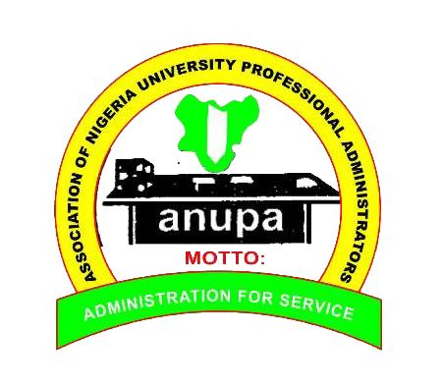
ASSOCIATION OF NIGERIAN UNIVERSITY PROFESSIONAL ADMINISTRATORS (ANUPA)
Present: Annual General Meeting/ Conference
Theme: Crisis, Collaboration and the Future of Higher Education
Date: Tuesday, 23rd to 27th November, 2021
Venue: Public Service Institute of Nigeria, (PSIN), Dutsen-Alhaji Junction, KM 30, Along Abuja-Kubwa Express Way, FCT, Abuja

PROGRAMME OF EVENTS
- Day One: Tuesday, 23rd November, 2021
12 Noon to 6:00 pm – Arrival/ Registration of Conferees/ Participants

- Day Two: Wednesday, 24th November, 2021
9:00 am to 11 am – Opening Ceremony/ Keynote Address/ Opening Address/ Registration of Conferees/ Participants Continues

11:00 am to 12:00 am – Tea Break

12:00 am to 2:00 pm – Lecture I
Topic: Leading Through Uncertainties: The Nigerian Higher Education and
the Pursuit of Excellence
Resource Person: Prof. Joy Eyisi

2:00 pm – 4:00 pm – Lecture II
Topic: Crisis of Leadership Succession: Challenges of Excellence in
Nigerian Universities
Resource Person: Alhaji M. Bukar Usman, FCIA

4:00 pm to 5 pm – Lunch

- Day Three: Thursday, 25th November, 2021
9:00 am to 11: 00 am – Lecture III
Topic: The Future of Higher Education in Nigeria: The Place of Professional
Administrators in Crisis Management
Resource Person: Mr. Ayo Ogunruku

11:00 am to 12:00 Noon – Tea Break

12:00 Noon to 2:00 pm – Lecture IV
Topic: Insights into the Fiscal Responsibility Act and Financial Discipline
(Prudent Resources Management) in the University
Resource Person: Dr. (Sir) W. O. Adebayo

2:00 pm to 3:00 pm – Lunch

3:00 pm to 5:00 pm – Lecture V
Topic: Collaborating for Excellence: The University Registry as a Catalyst
for Change and Innovation
Resource Person: Mrs. Ibimonia Harry

5:00 pm to 6:00 pm - Collection of Certificates by Attendees
7:00 pm to 9: 00 pm Buffet
- Day Four: Friday, 26th November, 2021
9:00 am to 11 am – Annual General Meeting/Presentation of Annual Accounts
11: am to 12 Noon – Tea Break
12 Noon to 3:00 pm – Elections into Positions in National Executive Committee – Electoral Committee
3:00 pm – 4 pm - Lunch

- Day Five: Saturday, 27th November, 2021 – Departure

