Work Ethics, Occupational Stress and Mental Health: The Challenges Facing Administrators in the Quest for Effective Performance in the University System
By
Dr. Omojola Awosusi
doctorawosusi@gmail.com
Former Registrar, Ekiti State University, Ado- Ekiti
Being a paper presented at the workshop organized by ANUPA held at Merit House, Abuja,
8-11 July, 2019.

- Introduction
It is necessary to commence this discussion by interrogating the basic concepts embedded in the topic namely work ethics, occupational stress, mental health and effective performance.
Work ethic is defined by Wikipedia as “a belief that hard work and diligence have a moral benefit and an inherent ability, virtue or value to strengthen character and individual abilities. It is a set of values centered on importance or desire to work hard”. Occupational Stress (OS) is the type of stress manifested in the workplace which threatens the focus, stamina and the internal alertness of a person, thereby reducing the individual’s ability to solve problems or to produce optimally (D’Archy, 2007). Mental health refers to a person’s condition with regard to his psychological and emotional well-being. Effective job performance will refer to a high degree of satisfactory delivery of services or the achievement of set objectives or mandate of an organization by its workers.
- Work Ethics
Ethics as a sociological or philosophical concept is the accepted standards of doing things in a particular culture or environment i.e., virtues that are acceptable as correct and right.
Workplace ethics or work ethics are the work behaviours that are taken as sacrosanct for the effective running of the organization. The workplace ethics are given standard or behavior such as integrity, honesty, loyalty and doing the right things at all times.
Ten workplace ethics that all employers look for and for which effective University administration can be rested include dependability and responsibility; positive attitude to work, adaptability, honesty, integrity, self-confidence, motivation to grow, learn and lead; teamwork capability, dedication, organizational skills, cooperation, respect for constituted authority and co- workers, leadership skills, professionalism and professional behavior, high productivity, determination to succeed and self-discipline. Work ethics of University administrators impose on them the prerequisites of loyalty, honesty, excellence, speed, job knowledge, grasp of regulations, adroitness, flawless expression of information, technical skill application and ability to keep confidential stuff safe.
- Job performance
Job performance refers to achievement of a given set of job descriptions by an employee in line with expected outcomes. There are 3 dimensions of job performance namely Task Performance, Organizational Citizenship Behavior and Deviant Behavior.
Task Performance has three divisions. The first is the routine task performance which involves work behaviours that transform activities into goods or services. The other aspect of task performance is the adaptive task performances which are the responses of employee to job demands that are novel, unexpected, and unusual. The third aspect is the creative task performance which is the degree of creativity and innovation of new ideas that accelerate the achievement of organizational goals.
Organizational citizenship behaviors (OCB) are positive voluntary behaviours which a worker shows but are not necessarily required for his job or stated in job description. No one also pays the workers for exhibiting these behaviours. These voluntary behaviours, though not rewarded, contribute immensely to the achievement of organizational objectives.
The behaviours are not enforceable and not recognized by the formal reward system.
OCB has 5 dimensions as suggested by Ogan (1988) namely Altruism, Conscientiousness, Sportsmanship, Courtesy and Civic Virtue. Altruism refers to readiness by a worker to help other employees undertake their workload. It is also called helping or helpfulness dimension. Conscientiousness refers to the habit of going the extra mile, working unpaid overtime and getting completely absorbed in the work. Sportsmanship is the willingness to tolerate minor temporary inconveniences and undue imposition of work without grievances or complaints. A sportsman at work usually avoid tension at among work team by sacrificing for others and showing understanding. When he loses out in a bid for a position or benefit, he allows it to go without grumbling or accusation.
Courtesy is demonstrated by avoiding creation of conflict, respecting the rights of others and not stepping on toes. Civic Virtue is demonstrated when an employee gets involved in all activities organized by the organization and identifying with anything the group identifies with. He speaks in defence of the organization in public to project its image positively.
Deviant behaviours are the direct opposite behaviour which employees exhibits intentionally to hinder the development of the organization. They are negative social behaviours. They are divided into 3 dimensions of property deviance, production deviance and political deviance.
Property deviance is demonstrated by staff through sabotage involving willful damage of physical assets and equipment (e.g. damage of a vehicle etc.). It is also reflected through theft, embezzlement and other fraudulent acts.
Political deviance manifests through gossips, malingering, rumour mongering, absenteeism, tale bearing, fighting, causing division and insubordination.
Production deviance affects the job directly through wastage of production materials such as chemicals, stationery etc. It also reveals itself through substance abuse such as taking alcohol at work.
The quality of employee performance can be measured through the dimensions of quality of work, quantity of work, timeliness of work, usage of resources (efficiency) and other indices
- Occupational Stress
Before attempting to define occupational stress, it will be great to, first, explain the concept of stress. Stress, in physics, refers to pressure exerted on a matter or body. Such pressure may manifest in the form of pushing a car, pulling a chain or an elastic fibre or hitting a surface with a hammer or any other metal. Marching on someone’s leg will impact on the victim’s flesh in form of inflicting injury and generating pains. Stress is a non- specific response of the body to any demand. It is a state of worry which arises from an actual or apparent demand that calls for change of behavior (Lazarus, 1999)
OS is an inevitable condition in the work environment which denotes mental, emotional and physical wear and tear arising from the clash between job requirements and employees’ capabilities and internal preparedness to flow with the demands of the job (Akinboye, Akinboye & Adeyemo 2002, Adeyemo and Ogunyemi 2005). Occupational stress (OS) refers to the type of stress imposed by the work environment and it is the physiological and physical effects of the negative activities experienced by a worker in the workplace.

- Manisfestation of Occupational Stress
Cary cooper identified six (6) sources of Occupational Stress namely,
- Job conditions: This involves quality of work, quantity of work, work overload, physical dangers
- Role stress: This involves role ambiguity, role conflict, gender bias, and sex role stereotypes.
- Interpersonal factors: This includes jealousy, anger, hatred, ethnicity, nepotism
- Career development: This involves issues of delayed promotion, job insecurity, non- inclusiveness in appointment of management officers.
- Organizational structure: This involves wrong or misplaced span of control, political postings
- Work life imbalance: This includes home interference with work, lack of spousal support, and work interference with home.
- Personality Determinants of Stress
Certain inherent factors in the individual may predispose them to stress at work. These include biological factors and environmental factors.
Biological factors include heredity, hormonal make-ups, glands, weight, height, etc. According to William Sheldon, there are three basic types of body make-ups with their different corresponding personality characteristics. We have
- THE ENDOMORPHIC BODY: This type of persons are round, fat and bulky. They can be tolerant, complacent, sociable, affectionate and easy going
- THE MESOMORPHIC BODY: They have hard, strong and muscular body. They can be aggressive, firm competitive, energetic and domineering.
- THE ECTOMORPHIC BODY: They have lean and delicate body frame. They are usually restrained, anxious, withdrawn but intellectual. Each of these body builds has implication of proneness to stress. They also have different degree of readiness to overcome the challenges imposed by occupational stress.
Environmental factor s include nature of family, school sy stem, economic factor and social values.
The different types of family setup( monogamy, polygamy, male headed family, female headed family, single- parent home, orphanage raised children, foster- mother raised children, etc. can affect the degree of self-confidence, socialization, initiative s and belief of a child. The type of school (co-educational or gives only schools), school curriculum, reward& reinforcement system, quality of teacher s, peer group influence, etc. all co-operate in shaping the personality of a growing child. Economic factor s include volume of income, in term s of salaries and allowance s, fringe benefit s attached by one’ s job and goodwill attracted by one’ s profession end up developing a per son’ s personality usually, lack of money imposes great stress on anyone at work and at home.
Social values system is a derivative of culture in some Nigerian culture, marriages and funerals attract heavy spending, quality and quantity of cloths, cars, houses may not just respond to the degree of one’s income but may be driven one’s social values, Inability to measure up at any point.
- The Good Side of Stress
While it is generated accepted that prolonged stress causes degeneration in the area of the brain responsible for self-control (Yale study), our brains are made in such a way that it takes some level of emotional state for any person to take action on anything. Performances of human being gets to the peak if and when activated by a moderate level of stress.
Kirhy Elizabeth of the University of California, Berkley asserted that it is important to keep stress under control but that the onset of stress helps the brain to function well and improves memory. Stressful events must happen intermittently to keep the brain alert.

Diagram Showing Relationship between Stress and Performance

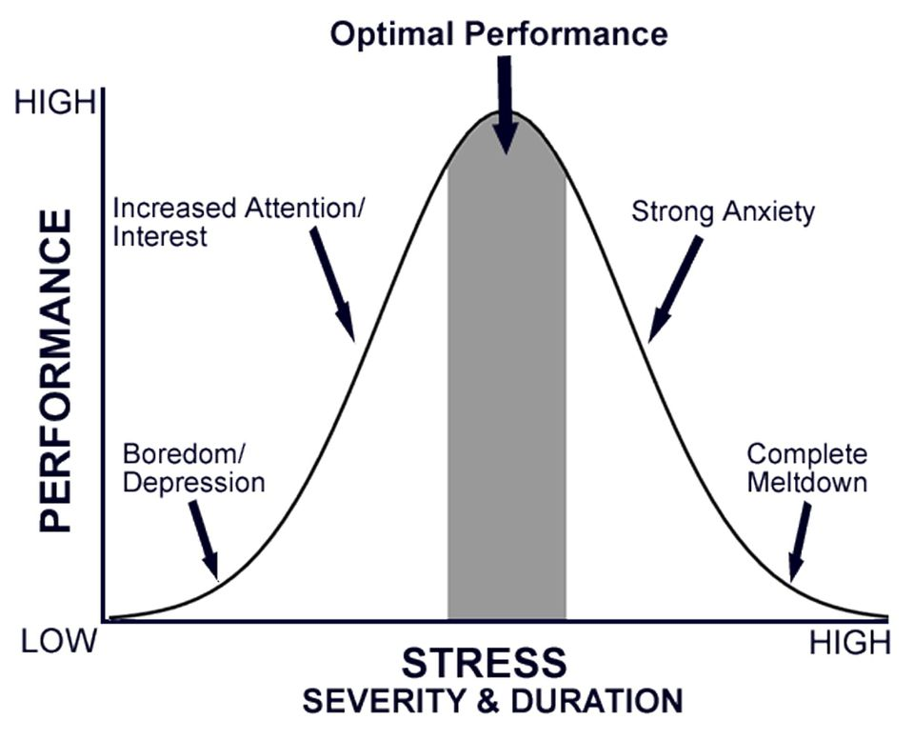

- Job Burnout
The extreme dimension of Occupational Stress is job burnout. According to Maslach and Jackson (1986), Job burnout is a psychological syndrome involving emotional exhaustion, depersonalization and a diminished sense of personal accomplishment which occurs among various professionals in challenging situations.
The first dimension of job burnout which is emotional exhaustion is characterized by depleted energy and a general feeling that one’s emotional resources have been drained (Corde and Dougherty, 2012). Associated with emotional exhaustion are feelings of anxiety, frets, and phobia for work and tension. The other dimension of depersonalization refers to the unconscious development in a worker of negative attitude of showing insensitivity, wickedness and callous behaviours to co-worker and customers (Schaufeli and Enzmann, 1998). The staff who are depersonalized abuse and curse people at work. The third dimension of job burnout is reduce personal accomplishment syndrome which is manifested by worker’s failure to rate positively his efficacy on the job. The employee perceives his performance. Adekola (2010) in his study of 1,040 staff of universities in South- West Nigeria found that workers had job burnout. According to him, there were gender differences in the predisposition of university staff to job burnout. He found that the female experienced higher level of reduced personal accomplishment while the male experienced higher level of depersonalization. There was of course no gender difference in the levels of emotional exhaustion. Nwabuoku and Adebayo (2010) in their study of nurses of the Ekiti State University Teaching Hospital found that frustrating daily hassles, lack of institutional support and absence of authority on the job were three major factors leading to burnout among nurses. In another study, Adebayo and Ezeanya (2010) in their study of health workers in Jos found that task identity and job autonomy negatively correlated with nurses’ experience of burnout.
- Technostress
Technostress is the negative psychological link between people and the introduction of new technologies. It is the accumulated stress acquired by an individual as a result of exposure to frequent use of the computer and other technological devices leading to information overload and health complications. Brod (1984) describes technostress as “a modern disease of adaptation, due to an individual’s lack of ability to cope with new computer technology in a healthy manner”. A number of ailments have been associated with the advent and protracted use of the computer.
- How University Administrators can Cope with Stress
University Administrators should adopt the strategies identified below against stress which must come to them in view of the sedentary nature of their jobs and the workload of their daily schedules:
- Appreciate what you have. Gratitude helps to deflate stress University of California Davis Study found that daily experience of gratitude improved mood, energy and physical well-being.
- Stop asking what if? Don’t keep worrying about possibilities. Calm people know that asking what if? May lead them to a place they don’t want to go.
- Stay positive. When things are going poorly, focus on the possibilities of breakthrough, success, or concentrate on the last good news or a great event coming up in the future.
- Disconnect from your routine - work, phone, emails, internet, whatsapp, etc.
- Limit your caffeine such as coffee, tobacco, cocoa drink, etc. Drinking caffeine triggers release of adrenaline which the source is of fight or flight response. The F or F response is what happens when a lion is chasing you. It’s good to have that when you see a lion or snake but if it happens when you receive a serious letter or a stinker, your emotions will overrun your behaviour
- Sleep well. Sleep recharges your brain, shuffles through the days memories, Stores some memory, discarding some memory in form of dreams, clears your head and makes you alert when you wake up
When you don’t sleep, you lose self-control, attention & your memory power reduces
- Eschew negative self-talk. Our negative thoughts are just thought not facts. Don’t talk your negative thought out.
- Reframe your perceptions. This is the ability to decide to see things in a different and more positive perspective
- Ensure that you breathe well and deliberately so when stressed. Take a couple of minutes to focus on your breathing. Just sit in a chair, put away all distractions and breathe and focus on it. This will prevent your mind from wandering. Technique of focusing on bed is by counting numbers of breathing in and out.
- Use your natural support system. It’s dangerous for you to attempt solving all problems by yourself. Get some people who can help you out of your weaknesses such as a subordinate who loves you, a mentor or a sympathetic boss. Many times, other people can see a solution that you can’t see because they aren’t emotional about the issues at stake.
- The Concept of Mental Health and the Nigerian landscape
Statistics have shown that one in four people in the world has been affected by mental illness at some point in their lives. 450 million people now live with mental disorders globally, 300 million suffer from depression, 21 million have schizophrenia, 50 million are patients of Alzheimer and one person dies from suicide attempts every 40 seconds.
In Nigeria, today, there is increasing spate of suicide attempts and many cases of suicide completion particularly among youths. A young man drank sniper because he failed UTME after several unsuccessful attempts to gain University admission. He actually scored above 200 in one particular occasion. A man took 2 bottles of sniper. A young lady posted a question on twitter asking her friends to choose either that she should die or live. She committed suicide because majority of the people chose death. Three young students of UNIABUJA watched their friends drown in a hotel in Abuja. They felt no qualms.
Mental health is reflected in how we think, feel and behave. It is a state of wellness in which one can conveniently realizes his potential, cope with normal stresses of life. Someone with good mental health can work productively, interact with people and makes his contribution to the society as a well do.
Those who have challenges with their normal health manifest certain signs which are noticeable by observers and those interacting with the patient on daily basis. Unfortunately, the affected people may himself be oblivious of the issues. The signs include
- A change in personality.
- He begins to act like a different person
- He does not feel like his usual normal self
- He exhibits unexplainable anger, fear, anxiety and experience mood swings
- He exhibits social withdrawal and isolation
- He becomes careless about his look, appearance, dressing and life
- He begins to develop a severe of hopelessness or feeling overwhelmed
- Manifestation of Mental Health Problems among University administrators
A fraction of our colleagues at work may show traces of mental illness at work. Your goodself, also, may be showing it without you knowing. The manifestations of mental health issues in University Administration can be noticed in the following examples of social behaviours at work.
- A staff who does not participate in any social event involving other colleagues in the department
- A staff who does not make contribution to anything good or bad
- A staff who does not greet people or respond to greetings
- A staff who does not smile or laugh even in the face of a loud joke.
- A staff who is always moody and sits in his/her corner always
- A staff who is cantankerous - always fighting people
- A staff who abuses all clients of the department - parents, students, staff, etc.
- A staff who is always afraid
- A staff who comes late regularly or play truant at work and refuses to change after several warnings, damning the consequences.
- A staff who refuses to complete the APER form when others are running up and down to beat the deadline for presenting staff for annual review
- A staff who is indulged in alcoholism, chain smoking or some other substances
- A staff who has stayed too long in a position as a result of lack of a critical qualification or due to incompetence such that he has turned into a sadist thereby hating everybody and himself.
- A staff who confronts constituted authority at will (without being a union leader), not minding the collateral consequences.
- A staff who is prone to having regular accidents at home and with his vehicles.
- A staff who have irresolvable conflict with his/her spouse and now live alone with or without a divorce
- Staff who always engage in domestic violence (beating his wife or her husband etc)

- Characteristics of Mental Health (Wellness) among University Administrators
National Mental Health Association of America lists the following ten characteristics of people who are mentally healthy, which are the indicators we should look out for among University administrators:
- They feel good about themselves.
- They do not become overwhelmed by emotion, such as fear, anger, love, guilt or anxiety
- They have lasting and satisfying relationships
- They feel comfortable with other people
- They can laugh at themselves and with others
- They have respect for themselves and for others
- They are able to accept life’s disappointments (being jilted, losing a job, losing out in a contest, etc.)
- They can meet life’s demands and handle their problems when they arise.
- They make their own decisions easily.
- They shapen their environment whenever possible and adjust to it when necessary.
- Solution to Mental Health Issues
- Psychotherapy
Treatment provided by a trained mental health professional. The process explains thoughts, feelings and behaviours to improve well-being.
Types of Psychotherapy include Cognitive behavioural therapy (CBT), Exposure therapy and Dialetical behavioural therapy
- Medication
This doesn’t cure mental health problems out rightly. However, medication helps in combination with psychotherapy methods to promote recovery of those knocked down by mental illness.
- Hospitalization
- Support Group – Peer support and African communalism help recovery
- Complementary and alternative medicine
- Self-help plan – Once an affected person comes to the realization that he needs help to overcome a strain of mental health issue, such individual may be ready to implement recovery strategies. One who is angry always may not be able to stop his anger but he may learn not to act based on his anger. The other way is for him to study the things that usually trigger anger and try to avoid such triggers.
- How to Help University Administrators who have Mental Health Challenges
- Show understanding
- Use emotional intelligence
- Manage such individuals by making friends with them
- Monitor their actions, inactions and degree of compliance with doctors/psychologists’ advise.
- Report critical life threatening cases to the Healthcare providers in the system and to management for necessary actions
- Organize training workshop on mental health for administrators

REFERENCES
Adebayo, S. O. and Ezeanya, I. D. (2010). Effects of Job Autonomy, Task Identity and Profession on Burnout among Health Workers in Jos, Nigeria.’ European Journal of Social Sciences. 14 (1): 116-124
Adekola, B. (2010). Gender Differences in the Experience of Burnout among University Staff’ African Journal of Business Management 4 (6): 886-889
Adekola, B. (2010). Work Burnout Experience among Non-Teaching Staff’ International Journal of Academic Research in Business and Social Sciences (1): 128-135
Adeyemo, D. A. and Ogunyemi, B. (2005). Emotional Intelligence and self-efficacy as predictors of Occupational Stress among Academic Staff in a Nigerian University. Lagos: Stirling- Holden Publishers (Nig) Limited
Akinboye, T.O.; Akinboye, D.O. and Adeyemo, D. A. (2002). Coping with Stress in Life and Workplace. Lagos: Stirling- Holden Publishers (Nig) Limited
Brod, C. (1984). Technostress: A Content Analysis: Kent State University
Maslach, C. and Jackson, S.E. (1986). Maslach Burnout Inventory Manual (2nd Ed,).Palo Alto, CA: Consulting Psychologistss Press

